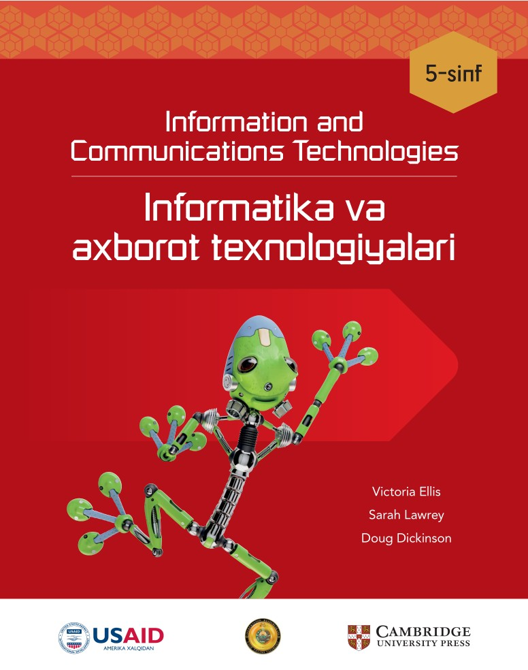

**________________________ viloyati**

**____________________________tumani**

**__-umumiy o‘rta ta’lim maktabi**

**___-“__”-sinf o‘quvchisi**

**_________________________________________________ning**

**Informatika fanidan**

**NAZORAT ISHLAR DAFTARI**

***1-Nazorat ishi Sana:_________________***

**1.** **Kompyuter nima uchun ishlatiladi?**

A) Faqat musiqalarni tinglash uchun

B) Hujjatlarni yaratish va tahrirlash uchun

C) Faqat internetdan foydalanish uchun

D) Faqat o'yin o'ynash uchun

**2.** **Microsoft Word dasturida matnni qayta ishlash uchun nima qilish kerak?**

A) Kompyuterni qayta yoqish

B) Matnni belgilash va tahrirlash

C) Kompyuter xavfsizlikni o'chirish

D) Internetga ulanish

**3.** **Matnli hujjatni chop etish uchun qaysi buyruq ishlatiladi?**

A) Save

B) Copy

C) Print

D) Cut

**4.** **Kompyuterda hujjatni qanday saqlash mumkin?**

A) Save buyrug'i orqali

B) Delete buyrug'i orqali

C) Print buyrug'i orqali

D) Copy buyrug'i orqali

**5.** **Matnni o'chirish uchun qaysi tugmani bosish kerak?**

A) Space

B) Shift

C) Enter

D) Backspace

**6.** **Matnni bosh harflarda yozish uchun qaysi tugma ishlatiladi?**

A) Caps Lock

B) Shift

C) Space

D) Tab

**7.** **Kompyuter xavfsizligiga rioya qilishda nimalardan saqlanish kerak?**

A) Suv to'kilishidan

B) Oziq-ovqat iste'molidan

C) Simlarga tegishdan

D) Barchasi to'g'ri

**8.** **Matnli hujjatni qayta saqlash uchun qaysi buyrug'idan foydalaniladi?**

A) Save as

B) Print

C) Cut

D) Copy

**9.** **Klaviaturada 'Caps Lock' tugmasining vazifasi nima?**

A) Belgilarni kichik harfda yozish

B) Belgilarni bosh harfda yozish

C) Bo'sh joy qo'yish

D) Tugmalarni o'chirish

**10.** **Matnni qaysi buyruq orqali yangi joyga joylashtirish mumkin?**

A) Save

B) Copy

C) Delete

D) Paste

**11.** **Klaviaturada belgini yuqori qismdagi belgiga o'tkazish uchun qaysi tugma ishlatiladi?**

A) Shift

B) Space

C) Tab

D) Enter

**12. Hujjatdagi imloviy xatolarni to'g'rilash uchun qaysi buyrug'idan foydalaniladi?**

A) Print

B) Copy

C) Spelling & Grammar

D) Delete

**13. Matnli hujjatda kursor nima vazifasini bajaradi?**

A) Hujjatni saqlash

B) Matn kiritiladigan joyni ko'rsatish

C) Kompyuterni yoqish

D) Simlarni ulash

**14. Hujjatga qo'shimcha matn kiritish uchun qaysi tugma bosiladi?**

A) Delete

B) Space

C) Enter

D) Shift

**15. Matn kiritish uchun qaysi qurilma ishlatiladi?**

A) Sichqoncha

B) Klaviatura

C) Printer

D) Monitor

**16. Klaviaturada nuqta yozish uchun qaysi tugmani bosish kerak?**

A) Shift

B) Space

C) Nuqta tugmasi

D) Enter

**17. Sichqonchaning qaysi tugmasi bilan matn belgilash mumkin?**

A) O'ng tugma

B) Chap tugma

C) O'rta tugma

D) A - B

**18. Matnli hujjatni bosmadan chiqarishdan avval nima qilish kerak?**

A) Save tugmasini bosish

B) Internetga ulanish

C) Kompyuterni o'chirish

D) Matnni qayta yozish

**19. Qanday qilib matnni belgilash va tahrirlash mumkin?**

A) Hujjatni saqlash orqali

B) Klaviatura yordamida

C) Matnni chop etish orqali

D) Sichqonchaning chap tugmasi bilan

**20. Microsoft Word dasturida hujjatni qanday nomlash kerak?**

A) Bosh joy bilan

B) Quyi chiziq bilan

C) Raqam bilan

D) Bo'sh qoldirish

|  |  |  |  |  |  |  |  |  |  |  |
| --- | --- | --- | --- | --- | --- | --- | --- | --- | --- | --- |
| **Savol** | **1** | **2** | **3** | **4** | **5** | **6** | **7** | **8** | **9** | **10** |
| **Javob** |  |  |  |  |  |  |  |  |  |  |
| **Savol** | **11** | **12** | **13** | **14** | **15** | **16** | **17** | **18** | **19** | **20** |
| **Javob** |  |  |  |  |  |  |  |  |  |  |

***2-Nazorat ishi Sana:_________________***

**1. Paint dasturida qaysi vosita yordamida egri chiziq chiziladi?**

A) Brush

B) Curved Line

C) Pencil

D) Line

**2. Tasvirni qayta o'zgartirish uchun qaysi buyruqdan foydalaniladi?**

A) Redo

B) Undo

C) Save

D) Print

**3. Qaysi uskuna yordamida qo'lda tasvir yaratish mumkin?**

A) Pencil

B) Line

C) Rectangle

D) Eraser

**4. Paint dasturida qanday qilib tasvirning bir qismidan nusxa olish mumkin?**

A) Cut va Paste

B) Print va Save

C) Select va Copy

D) Delete va Redo

**5. Shaklning ichini rang bilan to'ldirish uchun qaysi uskuna ishlatiladi?**

A) Pencil

B) Fill

C) Brush

D) Eraser

**6. Egri chiziq qaysi vosita yordamida hosil qilinadi?**

A) Line

B) Rectangle

C) Pencil

D) Curved Line

**7. Tasvirga rang berishda qaysi vosita ishlatiladi?**

A) Pencil

B) Line

C) Fill

D) Brush

**8. Paint dasturida chiziqning qalinligini qanday o'zgartirish mumkin?**

A) Size tugmasi orqali

B) Color tugmasi orqali

C) Eraser yordamida

D) Save orqali

**9. Paint dasturida tasvirning noto'g'ri qismini qanday o'chiramiz?**

A) Line

B) Select

C) Eraser

D) Copy

10. Tasvirni saqlash uchun qaysi buyruq ishlatiladi?

A) Print

B) Save

C) Cut

D) Paste

11. Paint dasturida to'rtburchak shaklni qanday hosil qilamiz?

A) Rectangle uskunasi yordamida

B) Pencil yordamida

C) Line yordamida

D) Brush yordamida

**12. Shaklning tashqi hoshiyasiga qanday rang beriladi?**

A) Brush

B) Color 2

C) Color 1

D) Size

**13. Tasvirni boshqa joyga joylash uchun qaysi buyruqdan foydalaniladi?**

A) Eraser va Line

B) Copy va Save

C) Cut va Paste

D) Fill va Brush

**14. Paint dasturida yangi tasvir yaratishda qaysi buyruqdan foydalaniladi?**

A) New

B) Save As

C) Open

D) Print

**15. Shaklning ichki qismini rang bilan to'ldirish uchun qaysi uskuna ishlatiladi?**

A) Pencil

B) Color 1

C) Brush

D) Fill

**16. Paint dasturida chizilgan tasvirni qanday qilib tahrir qilamiz?**

A) Eraser yordamida

B) Save yordamida

C) Select va Delete yordamida

D) Print yordamida

**17. Paint dasturida yangi tasvir yaratish uchun qaysi tugma kerak?**

A) New

B) Save

C) Print

D) Copy

**18. Paint dasturida qaysi buyruq yordamida oxirgi bajarilgan amalni bekor qilish mumkin?**

A) Redo

B) Undo

C) Save

D) Print

**19. Qanday qilib tasvirning bir qismini belgilaymiz?**

A) Select yordamida

B) Fill yordamida

C) Eraser yordamida

D) Copy yordamida

**20. Paint dasturida to'g'ri chiziq chizish uchun qaysi uskuna ishlatiladi?**

A) Eraser

B) Curved Line

C) Pencil

D) Line

To'g'ri javob: D

|  |  |  |  |  |  |  |  |  |  |  |
| --- | --- | --- | --- | --- | --- | --- | --- | --- | --- | --- |
| **Savol** | **1** | **2** | **3** | **4** | **5** | **6** | **7** | **8** | **9** | **10** |
| **Javob** |  |  |  |  |  |  |  |  |  |  |
| **Savol** | **11** | **12** | **13** | **14** | **15** | **16** | **17** | **18** | **19** | **20** |
| **Javob** |  |  |  |  |  |  |  |  |  |  |

***3-Nazorat ishi Sana:_________________***

**1. Qaysi dastur yordamida elektron jadvallar yaratiladi?**

A) Microsoft Excel

B) Microsoft Word

C) Paint

D) Notepad

**2. Qaysi diagramma turi butun miqdorning ulushlarini ko'rsatadi?**

A) Ustunli diagramma

B) Doiraviy diagramma

C) Chiziqli diagramma

D) Piktogramma

**3. Axborotni guruhlash deganda nimani tushunasiz?**

A) Ma'lumotni tahrirlash

B) Ma'lumotni tasvirlash

C) Ma'lumotlarni guruhlarga ajratish

D) Ma'lumotni saqlash

**4. Qaysi amaliy dastur orqali diagrammalar tuzish mumkin?**

A) Scratch

B) Word

C) Paint

D) Excel

**5. Ma'lumotlarni guruhlarga ajratishning qaysi usuli to'g'ri?**

A) Ma'lumotni bir-biriga aralashtirish

B) Axborotni qiymatini hisoblash

C) Ma'lumotlarni ranglariga qarab guruhlash

D) Tasvirni tahrirlash

**6. Diagrammadagi eng baland ustun nimani bildiradi?**

A) Eng kichik qiymatni

B) Eng katta qiymatni

C) O'rtacha qiymatni

D) Har qanday qiymatni

**7. Microsoft Excel dasturida kataklar qanday tanlanadi?**

A) Bitta bosish orqali

B) Katak ustiga o'ng tugmani bosib

C) Katak ustiga chap tugmani bir marta bosib

D) Katak ichiga ikki marta bosib

**8. Doiraviy diagramma qanday maqsad uchun ishlatiladi?**

A) Harakat ko'rsatish uchun

B) Piktogramma yaratish uchun

C) Grafik chizish uchun

D) Ma'lumotlarni ulushlarda ko'rsatish uchun

**9. Qaysi dastur orqali ma'lumotlar jadvalini yaratish mumkin?**

A) Paint

B) Word

C) Excel

D) Scratch

**10. Ustunli diagrammada nechta ustun bo'lishi mumkin?**

A) Faqat 2

B) Faqat 3

C) Har xil sonlarda

D) Faqat 5

**11. Piktogramma nima?**

A) Tasvirlardan foydalangan holda axborotni namoyish etish

B) Ma'lumotlarni chizish usuli

C) Chiziqli grafik

D) Harakat ko'rsatkichli grafik

**12. Doiraviy diagrammada eng katta bo'lak nimani bildiradi?**

A) Eng kichik ulushni

B) Eng katta ulushni

C) O'rtacha ulushni

D) Umumiy ulushni

**13. Scratch dasturida qaysi obyektni boshqarish mumkin?**

A) Katak

B) Diagramma

C) Piktogramma

D) Sprayt

**14. Scratch dasturida qaysi buyrug' yordamida obyekt harakatlanadi?**

A) Move

B) Turn

C) Jump

D) Slide

**15. Axborotni qanday usulda guruhlash mumkin?**

A) Qismlarga ajratish

B) Diagramma yaratish

C) Ranglariga qarab

D) Foydalanuvchilar bo'yicha

**16. Diagrammada ko'rsatilgan axborot qanday turlarga bo'linadi?**

A) Ustunli va doiraviy

B) Faqat chiziqli

C) Faqat rangli

D) Faqat matnli

**17. Excelda qaysi amal orqali diagrammalar tuziladi?**

A) Copy

B) Insert

C) delete

D) Open

**18. Qaysi diagramma ustunlardan tashkil topgan?**

A) Doiraviy diagramma

B) Chiziqli diagramma

C) Ustunli diagramma

D) Piktogramma

**19. Qaysi diagramma qiymatlarni ulushlar bo'yicha ko'rsatadi?**

A) Doiraviy diagramma

B) Ustunli diagramma

C) Piktogramma

D) Axborot jadvali

**20. Axborotni tahlil qilishda diagramma qanday yordam beradi?**

A) Ranglarni tanlashda

B) Axborotni ko'rinishda

C) Ma'lumotlarni guruhlashda

D) Ma'lumotlardan xulosa chiqarishda

|  |  |  |  |  |  |  |  |  |  |  |
| --- | --- | --- | --- | --- | --- | --- | --- | --- | --- | --- |
| **Savol** | **1** | **2** | **3** | **4** | **5** | **6** | **7** | **8** | **9** | **10** |
| **Javob** |  |  |  |  |  |  |  |  |  |  |
| **Savol** | **11** | **12** | **13** | **14** | **15** | **16** | **17** | **18** | **19** | **20** |
| **Javob** |  |  |  |  |  |  |  |  |  |  |

***4-Nazorat ishi Sana:_________________***

**1. Veb-brauzer nima?**

A) Ma'lumot qidirish tizimi

B) Internetda sahifalarni ko'rsatuvchi dastur

C) Kompyuter tarmog'i

D) Internet manbasi

**2. Qaysi bir qidiruv tizimi?**

A) Google

B) Microsoft Word

C) Windows

D) Adobe

**3. Qidiruv tizimi qanday ishlaydi?**

A) Veb sahifalarni yaratadi

B) Ma'lumotlarni saqlaydi

C) Ma'lumotlarni qidiradi

D) Tarmoqlarni boshqaradi

**4. Veb-sahifani qayta yuklash uchun qaysi tugma ishlatiladi?**

A) Ortga tugmasi

B) Oldinga tugmasi

C) Yangilash tugmasi

D) O'chirish tugmasi

**5. Kalit so'z bilan qidirishda qanday natijalar paydo bo'ladi?**

A) Faqat rasm

B) Ma'lumotlar

C) Sahifa sarlavhasi

D) Videolar

**6. Veb-sayt manzili nima deb ataladi?**

A) URL

B) IP

C) DNS

D) HTTP

**7. Qaysi biri mashhur veb-brauzer?**

A) PowerPoint

B) Microsoft Excel

C) Google Chrome

D) WordPress

**8. Qidiruv tizimlaridan foydalanishda xavfsizlik nima deb ataladi?**

A) Kalit so'z

B) Elektron xavfsizlik

C) Ma'lumot xavfsizligi

D) Brauzer xavfsizligi

**9. Veb-sahifada havola nima uchun kerak?**

A) Fayl yaratish

B) Matnni ko'rsatish

C) Sahifaga o'tish

D) Sahifani o'chirish

**10. Internetda qaysi xizmatlardan ma'lumot topish mumkin?**

A) Google

B) Windows

C) Excel

D) Paint

**11. Kalit so'zlardan qanday foyda bor?**

A) Ma'lumotlarni to'plash

B) Kompyuterni boshqarish

C) Tarmoq yaratish

D) Tezkor qidiruv

**12. Qaysi biri qidiruv natijalarini ko'rsatadi?**

A) Brauzer

B) Qidiruv tizimi

C) Veb-sayt

D) Tarmoq

**13. Ma'lumotlar qanday topiladi?**

A) Matn yozish orqali

B) Ortga tugmasi orqali

C) Kalit so'zlar orqali

D) Brauzerni yopish orqali

**14. Veb-brauzer nima uchun kerak?**

A) Veb sahifalarni ko'rish

B) Ma'lumotlar saqlash

C) Tarmoq yaratish

D) Axborot kiritish

**15. Kalit so'zdan qanday foydalaniladi?**

A) Brauzerni yopadi

B) Ma'lumotlarni topadi

C) Rasmlar yaratadi

D) Internet o'rnatadi

**16. Qaysi biri xavfsiz qidiruv usuli?**

A) Brauzerlarni yangilash

B) Internetni o'chirish

C) Ma'lumotni o'chirish

D) To'g'ri kalit so'zlar tanlash

**17. Qidiruv tizimi nima uchun ishlatiladi?**

A) Ma'lumot topish uchun

B) Veb-sayt yaratish uchun

C) Fayllarni saqlash uchun

D) Kompyuter o'rnatish uchun

**18. Internet xavfsizligi nima deb ataladi?**

A) Elektron xavfsizlik

B) Ma'lumot xavfsizligi

C) Tarmoq xavfsizligi

D) Kalit xavfsizligi

**19. Qaysi tugma sahifani qayta yuklaydi?**

A) Yangilash

B) Ortga

C) Oldinga

D) O'chirish

**20. Qaysi bir ma'lumotlar qidiruv tizimi hisoblanadi?**

A) Windows

B) Firefox

C) Microsoft Word

D) Google

|  |  |  |  |  |  |  |  |  |  |  |
| --- | --- | --- | --- | --- | --- | --- | --- | --- | --- | --- |
| **Savol** | **1** | **2** | **3** | **4** | **5** | **6** | **7** | **8** | **9** | **10** |
| **Javob** |  |  |  |  |  |  |  |  |  |  |
| **Savol** | **11** | **12** | **13** | **14** | **15** | **16** | **17** | **18** | **19** | **20** |
| **Javob** |  |  |  |  |  |  |  |  |  |  |

**Nazorat ishlar kaliti**

**1-Nazorat ishi**

|  |  |  |  |  |  |  |  |  |  |  |
| --- | --- | --- | --- | --- | --- | --- | --- | --- | --- | --- |
| **Savol** | **1** | **2** | **3** | **4** | **5** | **6** | **7** | **8** | **9** | **10** |
| **Javob** | **D** | **B** | **C** | **A** | **D** | **A** | **D** | **A** | **B** | **D** |
| **Savol** | **11** | **12** | **13** | **14** | **15** | **16** | **17** | **18** | **19** | **20** |
| **Javob** | **A** | **C** | **B** | **C** | **B** | **C** | **D** | **A** | **D** | **B** |

**2-Nazorat ishi**

|  |  |  |  |  |  |  |  |  |  |  |
| --- | --- | --- | --- | --- | --- | --- | --- | --- | --- | --- |
| **Savol** | **1** | **2** | **3** | **4** | **5** | **6** | **7** | **8** | **9** | **10** |
| **Javob** | **D** | **B** | **A** | **C** | **B** | **D** | **D** | **A** | **C** | **B** |
| **Savol** | **11** | **12** | **13** | **14** | **15** | **16** | **17** | **18** | **19** | **20** |
| **Javob** | **A** | **C** | **C** | **A** | **D** | **A** | **A** | **B** | **A** | **D** |

**3-nazorat ishi**

|  |  |  |  |  |  |  |  |  |  |  |
| --- | --- | --- | --- | --- | --- | --- | --- | --- | --- | --- |
| **Savol** | **1** | **2** | **3** | **4** | **5** | **6** | **7** | **8** | **9** | **10** |
| **Javob** | **A** | **B** | **C** | **D** | **C** | **B** | **C** | **D** | **C** | **C** |
| **Savol** | **11** | **12** | **13** | **14** | **15** | **16** | **17** | **18** | **19** | **20** |
| **Javob** | **A** | **B** | **D** | **A** | **C** | **A** | **B** | **C** | **A** | **D** |

**4-nazorat ishi**

|  |  |  |  |  |  |  |  |  |  |  |
| --- | --- | --- | --- | --- | --- | --- | --- | --- | --- | --- |
| **Savol** | **1** | **2** | **3** | **4** | **5** | **6** | **7** | **8** | **9** | **10** |
| **Javob** | **B** | **A** | **C** | **C** | **B** | **A** | **C** | **B** | **C** | **A** |
| **Savol** | **11** | **12** | **13** | **14** | **15** | **16** | **17** | **18** | **19** | **20** |
| **Javob** | **D** | **B** | **C** | **A** | **B** | **D** | **A** | **A** | **A** | **D** |