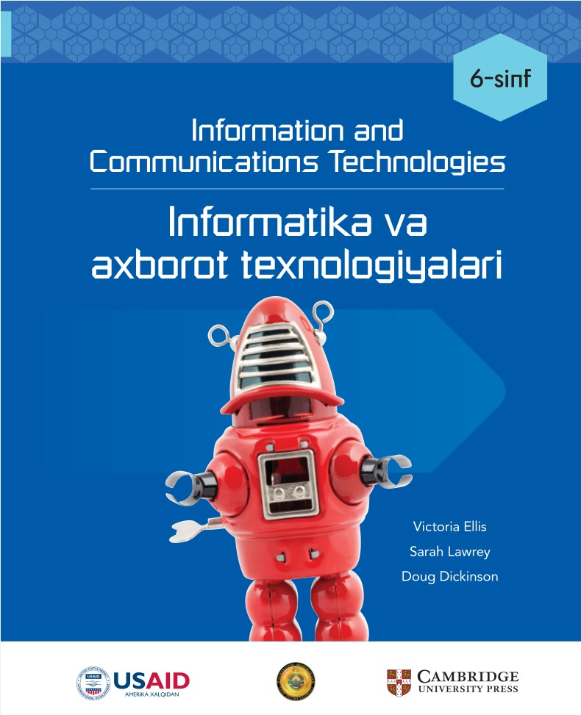

**________________________ viloyati**

**____________________________tumani**

**__-umumiy o‘rta ta’lim maktabi**

**___-“__”-sinf o‘quvchisi**

**_________________________________________________ning**

**Informatika fanidan**

**NAZORAT ISHLAR DAFTARI**

***1-Nazorat ishi Sana:_________________***

**1. Qaysi klaviatura tugmasi kursorni yangi qatorga olib o'tadi?**

A) BACKSPACE

B) ENTER

C) CAPS LOCK

D) SPACEBAR

**2. Hujjatda matnni tahrirlash uchun qaysi tugma ishlatiladi?**

A) ENTER

B) SHIFT

C) BACKSPACE

D) CAPS LOCK

**3. Matn ko'chirishda qaysi amaldan foydalaniladi?**

A) Copy va Paste

B) Bold va Italic

C) Delete va Undo

D) Save va Print

**4. SmartArt nima?**

A) Grafik obyekt

B) Matn kiritish dasturi

C) Rasmlarni kesish vositasi

D) Matnni tahrirlash vositasi

**5. Matn shriftini qanday o'zgartiramiz?**

A) File menyusi orqali

B) Insert menyusi orqali

C) View menyusi orqali

D) Home menyusi orqali

**6. Qaysi buyruq matnning qalin ko'rinishini ta'minlaydi?**

A) Italic

B) Bold

C) Underline

D) Strike-through

**7. Matnning rangini o'zgartirish qaysi menyuda amalga oshiriladi?**

A) Insert

B) Format

C) Design

D) Home

**8. Tasvir qo'shish qaysi menyuda amalga oshiriladi?**

A) Insert

B) Format

C) Design

D) Home

**9. Qaysi tugmalar matnni kesish va joylashtirish uchun ishlatiladi?**

A) Ctrl + C va Ctrl + V

B) Ctrl + A va Ctrl + P

C) Ctrl + X va Ctrl + V

D) Ctrl + B va Ctrl + I

**10. Rasmga hoshiya qo'shish qaysi menyuda amalga oshiriladi?**

A) Insert

B) Page Layout

C) Design

D) Home

**11. Tasvirni aylantirish qaysi vosita orqali amalga oshiriladi?**

A) Rotate

B) Flip

C) Crop

D) Align

**12. Qaysi buyruq sahifadagi barcha matnni markazga hizalaydi?**

A) Justify

B) Left Align

C) Right Align

D) Center

**13. Hujjatni qaysi formatda saqlash kompyuterda ochilishi uchun eng qulay?**

A) DOCX

B) JPG

C) PDF

D) TXT

**14. Qaysi buyruq tasvirni aylantirish imkoniyatini beradi?**

A) Rotate

B) Flip

C) Crop

D) Align

**15. Qaysi klaviatura tugmasi bosh harflarni kiritadi?**

A) Caps Lock

B) Shift

C) Backspace

D) Tab

**16. Sahifa chekkasiga rasm joylashtirish qaysi menyuda amalga oshiriladi?**

A) Home

B) Format

C) Design

D) Insert

**17. Klaviaturada qaysi tugma yordamida imlo xatolarini to'g'rilash mumkin?**

A) Delete

B) Shift

C) Spelling & Grammar

D) Ctrl

**18. Hujjatga rasmni joylashtirish uchun qaysi menyu tanlanadi?**

A) Insert

B) Home

C) Page Layout

D) View

**19. Matnning o'lchamini o'zgartirish qaysi menyu orqali amalga oshiriladi?**

A) Style

B) Paragraph

C) Font

D) Format

**20. Hujjatni chop etishdan avval qanday vositadan foydalaniladi?**

A) Paste

B) Save

C) Copy

D) Print Preview

|  |  |  |  |  |  |  |  |  |  |  |
| --- | --- | --- | --- | --- | --- | --- | --- | --- | --- | --- |
| **Savol** | **1** | **2** | **3** | **4** | **5** | **6** | **7** | **8** | **9** | **10** |
| **Javob** |  |  |  |  |  |  |  |  |  |  |
| **Savol** | **11** | **12** | **13** | **14** | **15** | **16** | **17** | **18** | **19** | **20** |
| **Javob** |  |  |  |  |  |  |  |  |  |  |

***2-Nazorat ishi Sana:_________________***

**1. Elektron jadval nima uchun ishlatiladi?**

A) Matnlarni tahrirlash uchun

B) Raqamlar ustida hisob-kitoblarni amalga oshirish uchun

C) Internetda qidiruv uchun

D) Grafiklar yaratish uchun

**2. Excel dasturida katak manzili qanday ifodalanadi?**

A) Ustun nomi va qator raqami

B) Faqat ustun nomi

C) Faqat qator raqami

D) Rang va raqam orqali

**3. Elektron jadvallarda formula qanday belgidan boshlanadi?**

A) %

B) =

C) +

D) -

**4. Elektron jadvalda qaysi belgidan foydalanib qo‘shish amali bajariladi?**

A) -

B) *

C) +

D) /

**5. Elektron jadvallarda ‘SUM’ funksiyasi nima qiladi?**

A) Raqamlarni ko‘paytiradi

B) Raqamlarni ayiradi

C) Raqamlarni bo‘ladi

D) Raqamlarni qo‘shadi

**6. Diagramma va grafiklar qanday maqsadda ishlatiladi?**

A) Matnni tahrirlash uchun

B) Hujjatlarni saqlash uchun

C) Internetga ulanish uchun

D) Ma'lumotlarni vizual ko‘rinishda aks ettirish uchun

**7. Excel dasturida qator nima?**

A) Gorizontal kataklar

B) Vertikal kataklar

C) Diagramma

D) Grafik

**8. ‘AVERAGE’ funksiyasi nima uchun ishlatiladi?**

A) Eng kichik raqamni aniqlash

B) O‘rtacha qiymatni hisoblash

C) Eng katta raqamni aniqlash

D) Raqamlarni bo‘lish

**9. Excel dasturida eng kichik qiymatni aniqlash uchun qaysi funksiya ishlatiladi?**

A) SUM

B) MAX

C) AVERAGE

D) MIN

**10. Diagramma qanday yaratilib, formatlanadi?**

A) Kataklarga rang berish orqali

B) Grafik qo‘shish orqali

C) Diagramma qo‘shish va o‘q sarlavhalarini o‘rnatish orqali

D) Matn kiritish orqali

**11. Excel dasturida eng katta qiymatni aniqlash uchun qaysi funksiya ishlatiladi?**

A) MAX

B) MIN

C) SUM

D) AVERAGE

**12. Excel dasturida katakning qalin chegarasini qanday hosil qilish mumkin?**

A) Copy

B) Borders buyrug‘i orqali

C) Paste

D) Delete

**13. Elektron jadvalda ‘IF’ funksiyasi qanday maqsadda ishlatiladi?**

A) Raqamlarni bo‘lish uchun

B) Matnni tahrirlash uchun

C) Shartli hisob-kitoblarni bajarish uchun

D) Diagramma yaratish uchun

**14. Elektron jadvallarda qator va ustunlarni qanday ko‘chiramiz?**

A) Copy va Paste yordamida

B) Delete yordamida

C) Borders yordamida

D) SUM yordamida

**15. Excel dasturida ‘COUNT’ funksiyasi nima qiladi?**

A) Kataklarning qiymatlarini ko‘paytiradi

B) Kataklarni bo‘ladi

C) Kataklardagi qiymatlarni hisoblaydi

D) Matnlarni tahrirlaydi

**16. Excel dasturida qanday qilib kataklardagi matnni tahrir qilamiz?**

A) Delete yordamida

B) Katakka ikki marta bosish orqali

C) Paste buyrug‘i orqali

D) SUM yordamida

**17. Excel dasturida formulalardan qanday nusxa olish mumkin?**

A) Copy va Paste yordamida

B) Borders yordamida

C) Diagramma yaratish orqali

D) Matnni o‘chirish orqali

**18. Excel dasturida ‘Print Preview’ buyrug‘i nima uchun ishlatiladi?**

A) Faylni saqlash uchun

B) Faylni chop etishdan avval ko‘rish uchun

C) Faylni chop etish uchun

D) Diagramma yaratish uchun

**19. Excelda hujjatni qanday formatlash mumkin?**

A) Raqamlarni kiritish orqali

B) Matnni o‘chirish orqali

C) Font, rang va chiziqlar yordamida

D) SUM funksiyasi yordamida

**20. Excel dasturida qaysi buyruq yordamida faylni saqlash mumkin?**

A) Delete

B) Copy

C) Print

D) Save

|  |  |  |  |  |  |  |  |  |  |  |
| --- | --- | --- | --- | --- | --- | --- | --- | --- | --- | --- |
| **Savol** | **1** | **2** | **3** | **4** | **5** | **6** | **7** | **8** | **9** | **10** |
| **Javob** |  |  |  |  |  |  |  |  |  |  |
| **Savol** | **11** | **12** | **13** | **14** | **15** | **16** | **17** | **18** | **19** | **20** |
| **Javob** |  |  |  |  |  |  |  |  |  |  |

***3-Nazorat ishi Sana:_________________***

**1. Qaysi dastur yordamida algoritmlar tuzish mumkin?**

A) Microsoft Word

B) Paint

C) Excel

D) Scratch

**2. Takrorlash sikli nima uchun ishlatiladi?**

A) Biror amalni bir marta bajarish uchun

B) Amallarni takroran bajarish uchun

C) Amallarni faqat teskari bajarish uchun

D) Ma'lumotlarni saqlash uchun

**3. Scratch dasturida 'pen down' bloki nima vazifani bajaradi?**

A) Sprayt chizishni boshlaydi

B) Spraytni harakatga keltiradi

C) Sprayt chizishni to'xtatadi

D) Spraytni o'chiradi

**4. Blok-sxema nima?**

A) Fayl saqlash usuli

B) Diagramma turi

C) Algoritmni tasvirlash vositasi

D) Ma'lumotlar bazasi

**5. Muntazam shakl chizishda nechta burilish amalga oshiriladi?**

A) Har safar 360 daraja

B) Tomonlar soniga qarab

C) 90 daraja

D) 180 daraja

**6. Dekompozitsiya qanday jarayon?**

A) Murakkab shaklni chizish jarayoni

B) Biror topshiriqni kichikroq qismga ajratish jarayoni

C) Grafik chizish jarayoni

D) Kompyuterni sozlash jarayoni

**7. Scratchda protsedura nima?**

A) Algoritmdan tashqari kod

B) Foydalanuvchi interfeysi

C) Kodlarning yig'ilgan bloki

D) Scratchning grafikasini yaratish vositasi

**8. Kvadrat chizishda har bir burilish qancha daraja bo'lishi kerak?**

A) 120

B) 60

C) 90

D) 45

**9. Scratchda qanday qilib spraytni kichiklashtirish mumkin?**

A) Size buyrug'i orqali

B) Pen up yordamida

C) Control menyusidan

D) Pen down yordamida

**10. Scratchda aylana chizish uchun nechta burilish kerak?**

A) 4

B) 360

C) 360 bo'linib qadamlar soniga

D) Barcha burilishlar teng bo'ladi

**11. Takrorlash buyrug'i qanday vazifa bajaradi?**

A) Faqat bitta buyruqni bajaradi

B) Biror buyruqni ko'p marta takrorlaydi

C) Dastur bajarilishini to'xtatadi

D) Protsedurani yakunlaydi

**12. Blok-sxemalarda savol qanday shakl bilan ifodalanadi?**

A) To'rtburchak

B) Dumaloq

C) Rombo

D) Ustunli chiziq

**13. Shakl chizishda sprayt necha qadam oldinga harakat qiladi?**

A) Burchakka qarab har xil

B) Doim 100 qadam

C) Har safar 50 qadam

D) Har bir shaklning tomoni bo'yicha farq qiladi

**14. Scratch dasturida qanday qilib shaklni bekor qilish mumkin?**

A) Scratchni o'chirish orqali

B) Erase all bloki yordamida

C) Pen down yordamida

D) Motion bloklarini bekor qilish orqali

**15. Scratchda aylana chizish uchun har bir burilish qancha daraja bo'lishi kerak?**

A) 360

B) 10

C) 90

D) 1

**16. Kvadrat shaklini qanday qilib soddalashtirish mumkin?**

A) Har safar chizish kerak

B) 4 marta oldinga yurib va burilishlarni takrorlash orqali

C) Burchaklarni hisoblash orqali

D) Kvadratni keyin bo'lib olish orqali

**17. Takrorlash va protseduralar dasturlashning qanday jihatlari bilan bog'liq?**

A) Murakkablikni oshirish

B) Jarayonlarni avtomatlashtirish va soddalashtirish

C) Chizish jarayonini ko'paytirish

D) Grafiklar yaratish

**18. Scratchda algoritmni qanday tuzish mumkin?**

A) Protsedurani yaratib

B) O'ng menyudan tanlab

C) Bloklarni ketma-ket joylashtirish orqali

D) To'g'ridan to'g'ri yozish orqali

**19. Blok-sxema qanday shaklni tasvirlaydi?**

A) Algoritmning ketma-ketligini

B) Grafiklardagi axborotni

C) Kodlarni tahrirlash uchun blok

D) Piktogrammalarni

**20. Scratch dasturida 'pen down' bloki nima vazifani bajaradi?**

A) Spraytni harakatga keltiradi

B) Sprayt chizishni boshlaydi

C) Sprayt chizishni to'xtatadi

D) Spraytni o'chiradi

|  |  |  |  |  |  |  |  |  |  |  |
| --- | --- | --- | --- | --- | --- | --- | --- | --- | --- | --- |
| **Savol** | **1** | **2** | **3** | **4** | **5** | **6** | **7** | **8** | **9** | **10** |
| **Javob** |  |  |  |  |  |  |  |  |  |  |
| **Savol** | **11** | **12** | **13** | **14** | **15** | **16** | **17** | **18** | **19** | **20** |
| **Javob** |  |  |  |  |  |  |  |  |  |  |

***4-Nazorat ishi Sana:_________________***

**1. URL manzil nima?**

A) Internet tarmog'i

B) Manzil paneli

C) Web sahifa sarlavhasi

D) Uniform Resource Locator

**2. Qaysi biri qidiruv tizimi?**

A) Wikipedia

B) Google

C) Excel

D) Word

**3. Manzil panelida qanday ma'lumot ko'rsatiladi?**

A) Veb-sahifa manzili

B) Veb-sahifa matni

C) Fayl turi

D) Rasm nomi

**4. Internetda xavfsiz ma'lumot topish uchun nima qilish kerak?**

A) Havolalarga e'tibor bermaslik

B) Ko'rsatilgan birinchi natijaga ishonish

C) Ishonchli manbalarni tanlash

D) Qidiruv tizimidan foydalanmaslik

**5. Veb-sahifani yangilash uchun qaysi tugma ishlatiladi?**

A) Ortga

B) Yangilash

C) O'chirish

D) Oldinga

**6. Axborotning ishonchliligi nima bilan belgilanadi?**

A) Kalit so'zlar

B) URL uzunligi

C) Sahifa rangi

D) Manba obro'si

**7. Qaysi kalit so'zlar ma'lumot qidirishda tez natija beradi?**

A) Uzoq gaplar

B) Ixtiyoriy so'zlar

C) Aniq kalit so'zlar

D) Tasodifiy so'zlar

**8. Qidiruv tizimida nima topiladi?**

A) Faqat rasm

B) Kalit so'zga mos natijalar

C) Web sahifa manzili

D) Veb-sahifa kodi

**9. Elektron xavfsizlik nima?**

A) Parolni unutish

B) Kalit so'z kiritish

C) Ma'lumotlarni himoya qilish

D) Veb-saytni yopish

**10. Qaysi biri elektron pochtaga tegishli?**

A) Word

B) Windows

C) Excel

D) Gmail

**11. Kalit so'z nima?**

A) Axborotni qidirish uchun ishlatiladigan so'z

B) Axborotni saqlash vositasi

C) Veb-sayt turi

D) Rasm formatining nomi

**12. Algoritm nima uchun kerak?**

A) Ma'lumotni saqlash

B) Axborot qidirish jarayonini boshqarish

C) Rasm yaratish

D) Kompyuter o'rnatish

**13. Brauzer nima uchun kerak?**

A) Veb-sahifalarni ko'rish

B) Kompyuter viruslarini yo'q qilish

C) Ma'lumotlarni yuklab olish

D) Axborotni saqlash

**14. Kompyuter xavfsizligini ta'minlash uchun nima qilish kerak?**

A) Tarmoqni o'chirish

B) Kalit so'zlarni saqlash

C) Ma'lumotlarni himoya qilish

D) Parolni unutish

**15. Indeks nima?**

A) Ma'lumotlar ro'yxati

B) Veb-sahifani ochish jarayoni

C) Veb-sahifa kodi

D) Axborotning sahifa raqami

**16. Emailda cc maydonini nima uchun ishlatiladi?**

A) Parol yaratish uchun

B) Axborotni o'chirish uchun

C) Kalit so'zni kiritish uchun

D) Nusxa jo'natish uchun

**17. Qaysi biri mashhur qidiruv tizimi?**

A) Excel

B) Word

C) Bing

D) PowerPoint

**18. Qaysi biri sahifani ko'rsatadigan dastur?**

A) Google Chrome

B) Windows

C) Microsoft Word

D) Excel

**19. Ma'lumotlarni xavfsiz qidirishda qaysi usul ishlatiladi?**

A) Ishonchsiz manbalarga o'tish

B) Kalit so'zlarni to'g'ri tanlash

C) Internetni o'chirish

D) Veb-sahifani yopish

**20. Veb-sayt manzili qayerda ko'rsatiladi?**

A) Brauzer manzil panelida

B) Kalit so'zlar ro'yxatida

C) Veb-sahifa pastida

D) Sahifa sarlavhasida

|  |  |  |  |  |  |  |  |  |  |  |
| --- | --- | --- | --- | --- | --- | --- | --- | --- | --- | --- |
| **Savol** | **1** | **2** | **3** | **4** | **5** | **6** | **7** | **8** | **9** | **10** |
| **Javob** |  |  |  |  |  |  |  |  |  |  |
| **Savol** | **11** | **12** | **13** | **14** | **15** | **16** | **17** | **18** | **19** | **20** |
| **Javob** |  |  |  |  |  |  |  |  |  |  |

**Nazorat ishlar kaliti**

**1-Nazorat ishi**

|  |  |  |  |  |  |  |  |  |  |  |
| --- | --- | --- | --- | --- | --- | --- | --- | --- | --- | --- |
| **Savol** | **1** | **2** | **3** | **4** | **5** | **6** | **7** | **8** | **9** | **10** |
| **Javob** | **B** | **C** | **A** | **A** | **D** | **B** | **D** | **A** | **C** | **C** |
| **Savol** | **11** | **12** | **13** | **14** | **15** | **16** | **17** | **18** | **19** | **20** |
| **Javob** | **A** | **D** | **A** | **A** | **B** | **D** | **C** | **A** | **C** | **D** |

**2-Nazorat ishi**

|  |  |  |  |  |  |  |  |  |  |  |
| --- | --- | --- | --- | --- | --- | --- | --- | --- | --- | --- |
| **Savol** | **1** | **2** | **3** | **4** | **5** | **6** | **7** | **8** | **9** | **10** |
| **Javob** | **B** | **A** | **B** | **C** | **D** | **D** | **A** | **B** | **D** | **C** |
| **Savol** | **11** | **12** | **13** | **14** | **15** | **16** | **17** | **18** | **19** | **20** |
| **Javob** | **A** | **B** | **C** | **A** | **C** | **B** | **A** | **B** | **C** | **D** |

**3-nazorat ishi**

|  |  |  |  |  |  |  |  |  |  |  |
| --- | --- | --- | --- | --- | --- | --- | --- | --- | --- | --- |
| **Savol** | **1** | **2** | **3** | **4** | **5** | **6** | **7** | **8** | **9** | **10** |
| **Javob** | **D** | **B** | **A** | **C** | **B** | **B** | **C** | **C** | **A** | **C** |
| **Savol** | **11** | **12** | **13** | **14** | **15** | **16** | **17** | **18** | **19** | **20** |
| **Javob** | **B** | **C** | **D** | **B** | **D** | **B** | **B** | **C** | **A** | **B** |

**4-nazorat ishi**

|  |  |  |  |  |  |  |  |  |  |  |
| --- | --- | --- | --- | --- | --- | --- | --- | --- | --- | --- |
| **Savol** | **1** | **2** | **3** | **4** | **5** | **6** | **7** | **8** | **9** | **10** |
| **Javob** | **D** | **B** | **A** | **C** | **B** | **D** | **C** | **B** | **C** | **D** |
| **Savol** | **11** | **12** | **13** | **14** | **15** | **16** | **17** | **18** | **19** | **20** |
| **Javob** | **A** | **B** | **A** | **C** | **A** | **D** | **C** | **A** | **B** | **A** |