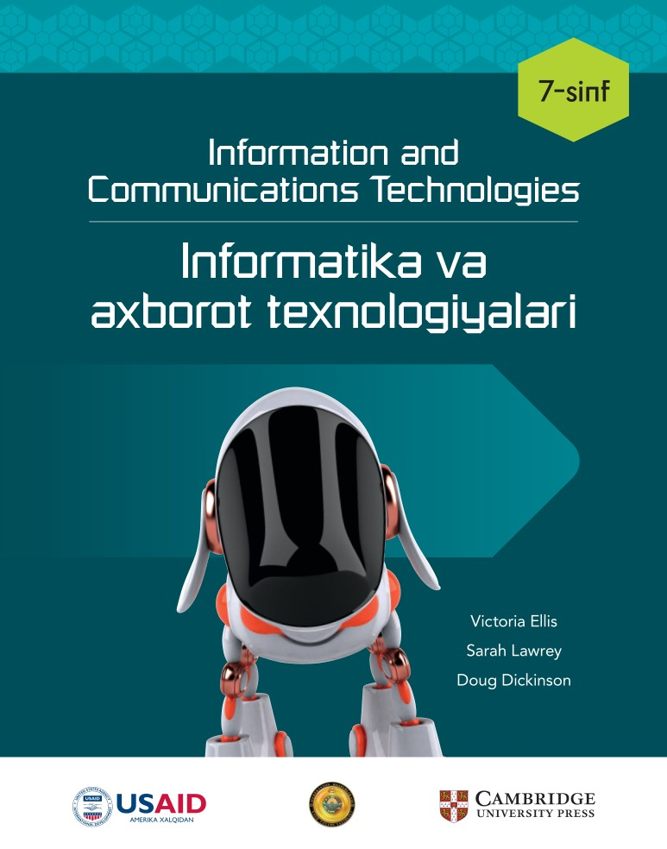

**________________________ viloyati**

**____________________________tumani**

**__-umumiy o‘rta ta’lim maktabi**

**___-“__”-sinf o‘quvchisi**

**_________________________________________________ning**

**Informatika fanidan**

**NAZORAT ISHLAR DAFTARI**

***1-Nazorat ishi Sana:_________________***

**1. Qaysi parametr hujjatdagi matnni o'ng va chap tomonga tenglashtiradi?**

A) Left Align

B) Center Align

C) Right Align

D) Justify

**2. Hujjatga qanday qilib rasm joylashtirish mumkin?**

A) Home menyusi orqali

B) Insert menyusi orqali

C) Layout menyusi orqali

D) View menyusi orqali

**3. Qaysi buyruq matn shriftini qalinlashtiradi?**

A) Bold

B) Italic

C) Underline

D) Strike-through

**4. Tasvirni qaysi menyu orqali o'zgartirish mumkin?**

A) Design

B) View

C) Format

D) Insert

**5. Hujjatga jadval qanday qo'shiladi?**

A) Insert menyusi orqali

B) Home menyusi orqali

C) Design menyusi orqali

D) View menyusi orqali

**6. Qaysi parametr matnni ustunlarga ajratadi?**

A) Format

B) Insert

C) Home

D) Layout

**7. Qaysi buyruq yordamida sahifa chegaralari o'rnatiladi?**

A) Page Borders

B) Page Layout

C) Margins

D) Line Spacing

**8. Hujjatning bitta sahifasiga qanday qilib boshqa formatni qo'llash mumkin?**

A) Format menyusi orqali

B) Layout menyusi orqali

C) Home menyusi orqali

D) Insert menyusi orqali

**9. Hujjatdagi qatorlar orasidagi bo'shliqni qanday o'zgartirish mumkin?**

A) Format

B) Paragraph

C) Style

D) Line Spacing

**10. Matnni ustunlarga qanday ajratish mumkin?**

A) Home menyusi orqali

B) View menyusi orqali

C) Layout menyusi orqali

D) Design menyusi orqali

**11. Qaysi buyruq yordamida jadvalga ustun qo'shish mumkin?**

A) Insert Above

B) Insert Left

C) Insert Right

D) Insert Below

**12. Sahifa formatini qanday o'zgartirish mumkin?**

A) Orientation

B) Margins

C) Page Layout

D) Borders

**13. Qaysi parametr orqali hujjatga raqamli ro'yxat qo'shiladi?**

A) Bullets

B) Numbering

C) Paragraph

D) Line Spacing

**14. Hujjatdagi sarlavhalarni qanday ajratib ko'rsatish mumkin?**

A) Font

B) Bold

C) Style

D) Italic

**15. Hujjatning pastki qismiga qanday qilib sana va vaqt qo'shiladi?**

A) Date & Time

B) Header

C) Footer

D) Page Layout

**16. Hujjatni chop etishdan oldin qanday buyruqdan foydalaniladi?**

A) Paste

B) Save

C) Copy

D) Print Preview

**17. Sahifa chegarasini qanday o'zgartirish mumkin?**

A) Margins

B) Layout

C) Insert

D) View

**18. Qaysi parametr yordamida tasvirni kesish mumkin?**

A) Cut

B) Resize

C) Crop

D) Paste

**19. Hujjatda qaysi parametr matnning rangini o'zgartiradi?**

A) Font Color

B) Background

C) Highlight

D) Paragraph

**20. Hujjatga giperhavola qanday qo'shiladi?**

A) Design menyusi orqali

B) Layout menyusi orqali

C) View menyusi orqali

D) Insert menyusi orqali

|  |  |  |  |  |  |  |  |  |  |  |
| --- | --- | --- | --- | --- | --- | --- | --- | --- | --- | --- |
| **Savol** | **1** | **2** | **3** | **4** | **5** | **6** | **7** | **8** | **9** | **10** |
| **Javob** |  |  |  |  |  |  |  |  |  |  |
| **Savol** | **11** | **12** | **13** | **14** | **15** | **16** | **17** | **18** | **19** | **20** |
| **Javob** |  |  |  |  |  |  |  |  |  |  |

***2-Nazorat ishi Sana:_________________***

**1. Multimediadan qanday maqsadli foydalaniladi?**

A) Taqdimotlar yaratish

B) Matnli hujjatlar tayyorlash

C) Faqat audio yozish

D) Faqat video tayyorlash

**2. Taqdimotda slayd o'tish effektlari nima uchun qo'llaniladi?**

A) Auditoriyani zeriktirish uchun

B) Auditoriyani jalb qilish uchun

C) Faqat texnik talablarga javob berish uchun

D) Matnni tahrirlash uchun

**3. Slaydga o'tish effektini qanday qo'shamiz?**

A) Insert menyusi orqali

B) Design menyusi orqali

C) Home menyusi orqali

D) Transitions menyusi orqali

**4. Taqdimot uchun qaysi fayl turi qo'llaniladi?**

A) .docx

B) .jpg

C) .xls

D) .pptx

**5. Taqdimotda qaysi vosita yordamida matnni harakatlantirish mumkin?**

A) Animations

B) Design

C) View

D) Insert

**6. Taqdimotda qanday qilib slaydga animatsiya qo'shish mumkin?**

A) Animation menyusi orqali

B) File menyusi orqali

C) Insert menyusi orqali

D) Design menyusi orqali

**7. Taqdimotda slaydlar o'rtasida qaysi vosita orqali o'tish mumkin?**

A) Mouse bosish orqali

B) Har qanday tugmani bosish orqali

C) O'tish effektlari orqali

D) Matnli hujjatlar orqali

**8. Taqdimotga qaysi elementlarni qo'shish mumkin?**

A) Faqat matn

B) Faqat video

C) Matn, audio va video

D) Faqat grafik

**9. Taqdimotda slaydga vaqtni qanday qo'shish mumkin?**

A) Insert menyusi orqali

B) Transitions menyusi orqali

C) Animations menyusi orqali

D) Design menyusi orqali

**10. Taqdimotda slayd o'tish vaqtini qanday sozlash mumkin?**

A) Duration menyusi orqali

B) Copy menyusi orqali

C) View menyusi orqali

D) Insert menyusi orqali

**11. Taqdimotda qanday qilib auditoriyani jalb qilish mumkin?**

A) Matnni kattalashtirish orqali

B) Ranglarni sozlash orqali

C) O'tish va animatsiya effektlarini ishlatish orqali

D) Faqat matn qo'shish orqali

**12. Taqdimotda qanday qilib audio qo'shish mumkin?**

A) Animations menyusi orqali

B) Insert menyusi orqali

C) Home menyusi orqali

D) Transitions menyusi orqali

**13. Qanday qilib taqdimotni avtomatlashtirish mumkin?**

A) Taqdimotga vaqt va o'tish effektlarini qo'shish orqali

B) Matn qo'shish orqali

C) Faqat video qo'shish orqali

D) Faqat grafik qo'shish orqali

**14. Animatsiya nima uchun ishlatiladi?**

A) Matnni saqlash uchun

B) Auditoriyani chalg'itish uchun

C) Slaydni qiziqarli qilish uchun

D) Faqat video qo'shish uchun

**15. Taqdimotga animatsiyalarni qanday qilib qo'shish mumkin?**

A) Insert menyusi orqali

B) Transitions menyusi orqali

C) Design menyusi orqali

D) Animations menyusi orqali

**16. Taqdimotda qanday qilib slayd o'tish vaqtini o'rnatish mumkin?**

A) Duration menyusi orqali

B) Copy menyusi orqali

C) View menyusi orqali

D) Insert menyusi orqali

**17. Slaydni qanday qilib avtomatik ravishda o'tkazish mumkin?**

A) Time va duration sozlash orqali

B) Copy orqali

C) Faqat video qo'shish orqali

D) Transitions menyusi orqali

**18. Taqdimotda qanday qilib animatsiyalarni tuzish mumkin?**

A) Design menyusi orqali

B) Animations menyusi orqali

C) View menyusi orqali

D) Insert menyusi orqali

**19. Taqdimotda qanday qilib ovozli nutqni yozib olish mumkin?**

A) Insert menyusi orqali

B) Animations menyusi orqali

C) Slide Show menyusi orqali

D) Transitions menyusi orqali

**20. Slaydni qanday qilib tayyor holatda chop etish mumkin?**

A) Print Preview menyusi orqali

B) View menyusi orqali

C) Insert menyusi orqali

D) Copy menyusi orqali

|  |  |  |  |  |  |  |  |  |  |  |
| --- | --- | --- | --- | --- | --- | --- | --- | --- | --- | --- |
| **Savol** | **1** | **2** | **3** | **4** | **5** | **6** | **7** | **8** | **9** | **10** |
| **Javob** |  |  |  |  |  |  |  |  |  |  |
| **Savol** | **11** | **12** | **13** | **14** | **15** | **16** | **17** | **18** | **19** | **20** |
| **Javob** |  |  |  |  |  |  |  |  |  |  |

***3-Nazorat ishi Sana:_________________***

**1. Elektron jadval nima?**

A) Ma'lumotlar bazasi

B) Matn tahrirlovchi dastur

C) Grafik chizuvchi dastur

D) Ma'lumotlar saqlash va hisoblash tizimi

**2. Microsoft Excel dasturida qanday funktsiyadan foydalaniladi?**

A) =AVERAGE

B) =COPY

C) =PASTE

D) =DRAW

**3. Formulalar qaysi belgi bilan boshlanadi?**

A) =

B) -

C) *

D) /

**4. Qaysi formula summani hisoblaydi?**

A) =SUM

B) =ADD

C) =MULT

D) =DIV

**5. Model nima uchun ishlatiladi?**

A) Grafik yaratish uchun

B) Formulalar yozish uchun

C) Ma'lumotlarni o'zgartirish va oqibatini ko'rish uchun

D) Jadvalni saqlash uchun

**6. Ssenariy nima?**

A) Elektron jadvalda kiritilgan ma'lumotlar

B) Kompyuterning ish rejasi

C) Biror vaziyatni tasvirlash

D) Grafik

**7. Modellashtirish jarayonida qaysi vosita ishlatiladi?**

A) Ma'lumotlar kiritish

B) Grafik tuzish

C) Ranglarni o'zgartirish

D) Formulalarni sinab ko'rish

**8. Katakdagi ma'lumotlarni qanday formatlash mumkin?**

A) Format menyusidan

B) Insert tugmasidan

C) Model bloki yordamida

D) SUM funksiyasi orqali

**9. Elektron jadvalda o'zgaruvchan qiymatlar nima uchun kerak?**

A) Ma'lumotlarni saqlash uchun

B) O'zgartirish uchun va natijalarni solishtirish uchun

C) Diagramma tuzish uchun

D) Jadvalni kengaytirish uchun

**10. Blok-sxema nimani ifodalaydi?**

A) Algoritmlarni

B) Grafiklarni

C) Kodlarni

D) Belgilangan vazifalarni

**11. Kataklar fon rangini qanday o'zgartirish mumkin?**

A) Format menyusidan

B) Bo'yash uskunasi bilan

C) Pen uskunasidan

D) Formula yordamida

**12. Excelda kataklar orasiga qanday chegara qo'yiladi?**

A) All borders buyrug'i bilan

B) SUM funksiyasi bilan

C) INSERT tugmasi bilan

D) Format menyusi bilan

**13. Katakdagi qiymatlar qanday tarzda modellashtiriladi?**

A) SUM buyrug'i orqali

B) Yangi katak qo'shib

C) Grafik orqali

D) Raqamlarni o'zgartirib

**14. Maqsadni qidirish nima?**

A) Jadvalni saqlash jarayoni

B) Yangi jadval yaratish jarayoni

C) Belgilangan qiymatga erishish uchun qiymatlarni o'zgartirish jarayoni

D) Formulalarni sinovdan o'tkazish jarayoni

**15. Maqsadli formatlash nima uchun ishlatiladi?**

A) Katakni ochish uchun

B) Jadvalni tahrirlash uchun

C) Ma'lumotlarni tanlash uchun

D) Ma'lumotlarga qarab katakning rangini o'zgartirish uchun

**16. Elektron jadval qanday vosita yordamida grafik yaratadi?**

A) Drawing tool

B) Insert bo'limi

C) SUM funksiyasi

D) Pen tool

**17. Elektron jadval nima uchun tekshiriladi?**

A) Formulalar to'g'ri ishlayotganini bilish uchun

B) Yangi jadval yaratish uchun

C) Jadvalni saqlash uchun

D) Kataklar rangini o'zgartirish uchun

**18. Kataklardagi ma'lumotlar qanday sinovdan o'tkaziladi?**

A) SUM funksiyasi orqali

B) Kalkulyator orqali natijalarni solishtirish

C) Ma'lumotlarni ko'chirish orqali

D) Ma'lumotlarni o'chirish orqali

**19. Elektron jadvalda ma'lumotlarni qanday formatlash mumkin?**

A) Chegara va rang qo'shish orqali

B) Ma'lumotlarni o'chirish orqali

C) Grafik tuzish orqali

D) SUM buyrug'ini qo'shish orqali

**20. Modellashtirish jarayonida qaysi vosita ishlatiladi?**

A) Ma'lumotlar kiritish

B) Grafik tuzish

C) Ranglarni o'zgartirish

D) Formulalarni sinab ko'rish

|  |  |  |  |  |  |  |  |  |  |  |
| --- | --- | --- | --- | --- | --- | --- | --- | --- | --- | --- |
| **Savol** | **1** | **2** | **3** | **4** | **5** | **6** | **7** | **8** | **9** | **10** |
| **Javob** |  |  |  |  |  |  |  |  |  |  |
| **Savol** | **11** | **12** | **13** | **14** | **15** | **16** | **17** | **18** | **19** | **20** |
| **Javob** |  |  |  |  |  |  |  |  |  |  |

***4-Nazorat ishi Sana:_________________***

**1. Ma'lumotlar bazasi nima uchun kerak?**

A) Axborotlarni to'plash uchun

B) Tarmoq yaratish uchun

C) Rasm chizish uchun

D) Video o'ynatish uchun

**2. Qaysi dastur ma'lumotlar bazasini boshqarish uchun ishlatiladi?**

A) Microsoft Access

B) Photoshop

C) Excel

D) Word

**3. Ma'lumotlar bazasida ma'lumotlar qanday saqlanadi?**

A) Video

B) Grafikalar

C) Slaydlar

D) Jadvallar

**4. Qaysi biri ma'lumotlar bazasida saqlanadigan element?**

A) Video

B) Matn

C) Rasm

D) Web sahifa

**5. Axborot xavfsizligi uchun nima kerak?**

A) Parol

B) Rasm

C) Slayd

D) Sahifa

**6. Ma'lumotlar bazasiga kirishda foydalanuvchi nima kiritadi?**

A) Rasm

B) Parol

C) Slayd

D) Web sahifa

**7. Qaysi biri ma'lumotlar bazasida turli maydonlarga tegishli?**

A) Dastur

B) Video

C) Rasm

D) Manzil

**8. Elektron jadvalda ma'lumotlar qanday saqlanadi?**

A) Slaydlarda

B) Grafiklarda

C) Kataklarda

D) Videoda

**9. Ma'lumotlar bazasidan qanday ma'lumot olish mumkin?**

A) Rasm chizish orqali

B) So'rov yuborish orqali

C) Slayd yaratish orqali

D) Video ko'rish orqali

**10. Ma'lumotlar bazasida qanday elementlar mavjud?**

A) Rasmlar va videolar

B) Maydonlar va jadvallar

C) Grafikalar va slaydlar

D) Web sahifalar

**11. Qaysi biri ma'lumotlar bazasiga tegishli dastur?**

A) Microsoft PowerPoint

B) Adobe Photoshop

C) Microsoft Access

D) Microsoft Word

**12. Ma'lumotlarni qanday qilib xavfsiz saqlash mumkin?**

A) Parol bilan himoya qilish orqali

B) Rasm qo'shish orqali

C) Slaydlar yaratish orqali

D) Video o'ynatish orqali

**13. Ma'lumotlar bazasida so'rov nima?**

A) Slaydlar qo'shish

B) Rasm chizish

C) Video yaratish

D) Axborotni qidirish

**14. Ma'lumotlar bazasiga qanday fayllar kiritilishi mumkin?**

A) Slaydlar va grafikalar

B) Matn va raqamlar

C) Rasmlar va videolar

D) Web sahifalar

**15. Ma'lumotlar bazasidan qanday foydalanish mumkin?**

A) Grafika yaratish

B) Video o'ynatish

C) Axborotni qidirish va qayta ishlash

D) Rasm chizish

**16. Ma'lumotlarni qanday turli dasturlarga yuborish mumkin?**

A) Rasm chizish orqali

B) Eksport qilish orqali

C) Slaydlar yaratish orqali

D) Video qo'shish orqali

**17. Qaysi biri axborot xavfsizligini ta'minlaydi?**

A) Video

B) Rasm

C) Parol

D) Web sahifa

**18. Ma'lumotlar bazasida maydon qanday bo'ladi?**

A) Web sahifa turi

B) Rasmning turi

C) Videoning turi

D) Jadvalda bir ma'lumot turi

**19. Ma'lumotlar bazasida qaysi biri ma'lumotlarni boshqarish uchun ishlatiladi?**

A) Adobe Photoshop

B) Microsoft Excel

C) PowerPoint

D) Microsoft Access

**20. Qaysi biri ma'lumotlar bazasidan maqsadli foydalanishga misol bo'la oladi?**

A) Axborotni saqlash va qidirish

B) Rasm chizish

C) Video yaratish

D) Slayd ko'rsatish

|  |  |  |  |  |  |  |  |  |  |  |
| --- | --- | --- | --- | --- | --- | --- | --- | --- | --- | --- |
| **Savol** | **1** | **2** | **3** | **4** | **5** | **6** | **7** | **8** | **9** | **10** |
| **Javob** |  |  |  |  |  |  |  |  |  |  |
| **Savol** | **11** | **12** | **13** | **14** | **15** | **16** | **17** | **18** | **19** | **20** |
| **Javob** |  |  |  |  |  |  |  |  |  |  |

**Nazorat ishlar kaliti**

**1-Nazorat ishi**

|  |  |  |  |  |  |  |  |  |  |  |
| --- | --- | --- | --- | --- | --- | --- | --- | --- | --- | --- |
| **Savol** | **1** | **2** | **3** | **4** | **5** | **6** | **7** | **8** | **9** | **10** |
| **Javob** | **D** | **B** | **A** | **C** | **A** | **D** | **A** | **B** | **D** | **C** |
| **Savol** | **11** | **12** | **13** | **14** | **15** | **16** | **17** | **18** | **19** | **20** |
| **Javob** | **C** | **A** | **B** | **C** | **A** | **D** | **A** | **C** | **A** | **D** |

**2-Nazorat ishi**

|  |  |  |  |  |  |  |  |  |  |  |
| --- | --- | --- | --- | --- | --- | --- | --- | --- | --- | --- |
| **Savol** | **1** | **2** | **3** | **4** | **5** | **6** | **7** | **8** | **9** | **10** |
| **Javob** | **A** | **B** | **D** | **D** | **A** | **A** | **C** | **C** | **C** | **A** |
| **Savol** | **11** | **12** | **13** | **14** | **15** | **16** | **17** | **18** | **19** | **20** |
| **Javob** | **C** | **B** | **A** | **C** | **D** | **A** | **A** | **B** | **C** | **A** |

**3-nazorat ishi**

|  |  |  |  |  |  |  |  |  |  |  |
| --- | --- | --- | --- | --- | --- | --- | --- | --- | --- | --- |
| **Savol** | **1** | **2** | **3** | **4** | **5** | **6** | **7** | **8** | **9** | **10** |
| **Javob** | **D** | **A** | **A** | **A** | **C** | **C** | **D** | **A** | **B** | **A** |
| **Savol** | **11** | **12** | **13** | **14** | **15** | **16** | **17** | **18** | **19** | **20** |
| **Javob** | **B** | **A** | **D** | **C** | **D** | **B** | **A** | **B** | **A** | **D** |

**4-nazorat ishi**

|  |  |  |  |  |  |  |  |  |  |  |
| --- | --- | --- | --- | --- | --- | --- | --- | --- | --- | --- |
| **Savol** | **1** | **2** | **3** | **4** | **5** | **6** | **7** | **8** | **9** | **10** |
| **Javob** | **A** | **A** | **D** | **B** | **A** | **B** | **D** | **C** | **B** | **B** |
| **Savol** | **11** | **12** | **13** | **14** | **15** | **16** | **17** | **18** | **19** | **20** |
| **Javob** | **C** | **A** | **D** | **B** | **C** | **B** | **C** | **D** | **D** | **A** |