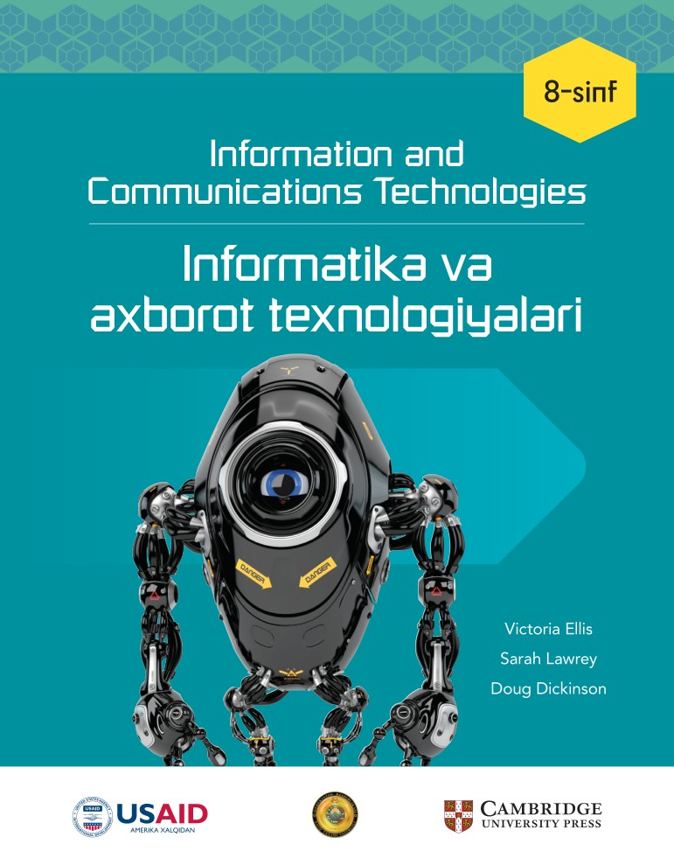

**________________________ viloyati**

**____________________________tumani**

**__-umumiy o‘rta ta’lim maktabi**

**___-“__”-sinf o‘quvchisi**

**_________________________________________________ning**

**Informatika fanidan**

**NAZORAT ISHLAR DAFTARI**

***1-Nazorat ishi Sana:_________________***

**1. Scratchda qanday buyruq yordamida spraytni harakatlantirish mumkin?**

A) Move 10 steps

B) Say Hello

C) Wait

D) Change Color

**2. Kompyuter qanday ma'lumotlar bilan ishlaydi?**

A) Analog ma'lumotlar

B) Raqamli ma'lumotlar

C) Barcha ma'lumotlar

D) Faol ma'lumotlar

**3. Scratchda o'zgaruvchini qanday yaratish mumkin?**

A) File menyusi orqali

B) Sensing menyusi orqali

C) Motion menyusi orqali

D) Variables menyusi orqali

**4. Foydalanuvchi bilan o'zaro aloqa qilish uchun qaysi blokdan foydalaniladi?**

A) Wait

B) Ask

C) Move

D) Play Sound

**5. Qaysi buyruq yordamida kompyuter vaqtni kuzatadi?**

A) Timer

B) Wait

C) Forever

D) If

**6. Scratch dasturida translyatsiya qilish nima?**

A) Tasvirni almashtirish

B) Xabar yuborish

C) Ma'lumot saqlash

D) Tasvirni tahrirlash

**7. Scratch dasturida qanday qilib ko'rsatma beriladi?**

A) Say

B) Set

C) When green flag clicked

D) Wait

**8. Scratch dasturida tanlash operatori qanday ishlaydi?**

A) Faqat Ha javobini beradi

B) Hech qanday javob bermaydi

C) Faqat Yo'q javobini beradi

D) If-else operatori orqali

**9. Scratchda vaqtni qanday belgilash mumkin?**

A) Forever bloklari orqali

B) Say va Move bloklari orqali

C) Timer va Wait bloklari orqali

D) Play Sound bloklari orqali

**10. Qaysi blok o'zgaruvchining qiymatini o'zgartiradi?**

A) Set block

B) Change block

C) Reset block

D) Wait block

**11. Scratchda qanday qilib yangi kostyum qo'shish mumkin?**

A) Motion menyusi orqali

B) Costumes menyusi orqali

C) Sound menyusi orqali

D) Events menyusi orqali

**12. Foydalanuvchi kiritgan ma'lumotlarni qanday tekshirish mumkin?**

A) Control bloki yordamida

B) Motion bloki yordamida

C) Looks bloki yordamida

D) Answer bloki yordamida

**13. Foydalanuvchi kompyuterga qanday qilib ma'lumot kiritadi?**

A) Kompyuterdan chiqarish orqali

B) Natijani chiqarish orqali

C) Kiritish va natijani chiqarish orqali

D) To'g'ridan-to'g'ri chiqarish orqali

**14. Qaysi blok yordamida kompyuter foydalanuvchining harakatlarini aniqlaydi?**

A) Sensing bloki

B) Motion bloki

C) Looks bloki

D) Sound bloki

**15. Scratchda qaysi blok yordamida foydalanuvchidan ism so'rash mumkin?**

A) Ask block

B) Wait block

C) Say block

D) Move block

**16. O'yinni dasturlashda qanday reja yaratiladi?**

A) Jadval

B) Chart

C) Diagramma

D) Blok-sxema

**17. O'yindagi to'qnashuvni qanday aniqlash mumkin?**

A) Touching color bloki orqali

B) Say bloki orqali

C) Wait bloki orqali

D) Move bloki orqali

**18. Qaysi blok yordamida ma'lumotlar kiritilishi yoki natijalar chiqarilishi mumkin?**

A) Sound

B) Motion

C) Sensing

D) Control

**19. Scratchda qanday qilib foydalanuvchi natijasini qayta ko'rish mumkin?**

A) Answer bloki yordamida

B) Sensing bloki yordamida

C) Sound bloki yordamida

D) Looks bloki yordamida

**20. O'zgaruvchini qanday qilib qayta o'rnatish mumkin?**

A) Reset block

B) Set block

C) Change block

D) Play block

|  |  |  |  |  |  |  |  |  |  |  |
| --- | --- | --- | --- | --- | --- | --- | --- | --- | --- | --- |
| **Savol** | **1** | **2** | **3** | **4** | **5** | **6** | **7** | **8** | **9** | **10** |
| **Javob** |  |  |  |  |  |  |  |  |  |  |
| **Savol** | **11** | **12** | **13** | **14** | **15** | **16** | **17** | **18** | **19** | **20** |
| **Javob** |  |  |  |  |  |  |  |  |  |  |

***2-Nazorat ishi Sana:_________________***

**1. HTML nimani ifodalaydi?**

A) Hyper Text Markup Language

B) Hyperlink Text Markup Language

C) Hyper Transfer Markup Language

D) Hyper Transfer Media Language

**2. HTML dasturining asosiy vazifasi nima?**

A) Matnli hujjatlarni tahrirlash

B) Veb-sahifalarni yaratish

C) Video muharrir

D) Audio fayllarni tahrirlash

**3. Veb-sahifa uchun qaysi format ishlatiladi?**

A) .pdf

B) .docx

C) .jpg

D).html

**4. HTML kodining asosiy tuzilmasi qaysi teg bilan boshlanadi?**

A) <html>

B) <body>

C) <title>

D) <head>

**5. Veb-sahifa sarlavhasini qanday teg ichida kiritamiz?**

A) <head>

B) <body>

C) <title>

D) <html>

**6. HTMLda sarlavhalar qanday yoziladi?**

A) <p1> dan <p6> gacha

B) <title> dan <title6> gacha

C) <h6> dan <h1> gacha

D) <h1> dan <h6> gacha

**7. Veb-sahifa matnini qanday qilib formatlash mumkin?**

A) <p> tegi orqali

B) <html> tegi orqali

C) <h1> tegi orqali

D) <head> tegi orqali

**8. Veb-sahifadagi elementlarni qanday qilib markazga joylashtiramiz?**

A) <align>

B) <center>

C) <mark>

D) <right>

**9. HTMLda rasmni qanday qilib kiritamiz?**

A) <img href>

B) <img src>

C) <pic>

D) <image>

**10. Veb-sahifa dizaynida matn va tasvirlar qanday qilib qo'shiladi?**

A) JavaScript yordamida

B) Faqat HTML yordamida

C) Faqat CSS yordamida

D) HTML va CSS yordamida

**11. Veb-sahifada navigatsiyani qanday tashkil qilish mumkin?**

A) Matnni tahrirlash orqali

B) Tasvirlar yordamida

C) Havolalar orqali

D) Faqat sarlavhalar orqali

**12. Giperhavola qanday teg bilan yaratiladi?**

A) <a>

B) <link>

C) <src>

D) <href>

**13. Veb-sahifaga tasvir qanday formatda kiritiladi?**

A) PDF

B) DOCX

C) JPG, PNG yoki GIF

D) MP3

**14. Tasvir o'lchamini qanday qilib belgilaymiz?**

A) <img src='rasm.jpg' width='500'>

B) <img src='rasm.jpg' size='500'>

C) <img src='rasm.jpg' length='500'>

D) <pic src='rasm.jpg' width='500'>

**15. Veb-sahifa fonini qanday o'zgartiramiz?**

A) <body style='background-color:lightblue;'>

B) <html style='background-color:blue;'>

C) <title style='background-color:green;'>

D) <img src='background.jpg'>

**16. Veb-sahifa sarlavhasini qanday ko'rsatamiz?**

A) <img>

B) <h1>

C) <p>

D) <table>

**17. Veb-sahifada havolani qanday qo'shamiz?**

A) <a href='example.html'>

B) <link href='example.html'>

C) <img src='example.html'>

D) <body href='example.html'>

**18. Veb-sahifaga qanday qilib jadval qo'shish mumkin?**

A) <link>

B) <img>

C) <title>

D) <table>

**19. HTML kodlarida matn rangini qanday o'zgartiramiz?**

A) <h1 style='red'>

B) <p style='background:red;'>

C) <p style='color:red;'>

D) <p color='blue'>

**20. Veb-sahifa faylini qanday saqlash kerak?**

A) .html kengaytmasi bilan

B) .txt kengaytmasi bilan

C) .pdf kengaytmasi bilan

D) .docx kengaytmasi bilan

|  |  |  |  |  |  |  |  |  |  |  |
| --- | --- | --- | --- | --- | --- | --- | --- | --- | --- | --- |
| **Savol** | **1** | **2** | **3** | **4** | **5** | **6** | **7** | **8** | **9** | **10** |
| **Javob** |  |  |  |  |  |  |  |  |  |  |
| **Savol** | **11** | **12** | **13** | **14** | **15** | **16** | **17** | **18** | **19** | **20** |
| **Javob** |  |  |  |  |  |  |  |  |  |  |

***3-Nazorat ishi Sana:_________________***

**1. Tarmoq topologiyasi nimani anglatadi?**

a) Tarmoqning xavfsizlik darajasi

b) Internetga ulanish turi

c) Tarmoqning joylashuvi

d) Kompyuter soni

**2. Qaysi tarmoq turi kichik geografik hududda ishlaydi?**

a) WAN

b) MAN

c) PAN

d) LAN

**3. Bluetooth nima?**

a) Ma'lumotlarni simli uzatish usuli

b) Ma'lumotlarni simsiz uzatish usuli

c) Ma'lumotlarni saqlash usuli

d) Tarmoqlarni boshqarish usuli

**4. Shaxsiy hududiy tarmoq (PAN) qachon ishlatiladi?**

a) Barcha internet foydalanuvchilari uchun

b) Faqat bitta qurilmaga ma'lumot uzatish uchun

c) Bir nechta qurilmalar o'rtasida

d) Juda katta tarmoqlar uchun

**5. Router nima vazifani bajaradi?**

a) Kompyuterlarga grafiklar yaratish

b) Tarmoq va internetni ulash

c) Kompyuterlar orasidagi kabellarni sozlash

d) Faqat printerlarni boshqarish

**6. Kompyuter xavfsizligi uchun qaysi vosita ishlatiladi?**

a) Antivirus

b) Paint

c) Word

d) Excel

**7. Tarmoq xavfsizligi qanday ta’minlanadi?**

a) Faqat internetga ulanish bilan

b) Printerlardan foydalanish bilan

c) Kompyuter o'yinlari o'ynash bilan

d) Fayervollar va shifrlash orqali

**8. Keng maydonli tarmoq (WAN) qanday tarmoqlarni qamrab oladi?**

a) Faqat bir nechta kompyuterlarni

b) Butun mamlakat yoki dunyo miqyosidagi tarmoqlarni

c) Uy ichidagi kompyuterlarni

d) Faqat maktab tarmoqlarini

**9. Modem nima uchun kerak?**

a) Fayllarni saqlash uchun

b) Kompyuterni yoqish uchun

c) Telefon liniyalari orqali internetga ulanish uchun

d) Axborotlarni chop etish uchun

**10. Ethernet nima?**

a) Internetga ulanish usuli

b) Kompyuter o'yini

c) Kompyuter grafikasi

d) Elektron pochta

**11. Tarmoqda qanday komponentlar mavjud?**

a) Faqat bitta kompyuter

b) Kompyuterlar, kabellar va routerlar

c) Faqat printerlar

d) Faqat internet

**12. Server nima vazifani bajaradi?**

a) Elektron pochtalarni boshqaradi

b) Faqat ma'lumotlarni chop etadi

c) Faqat printerlar bilan ishlaydi

d) Tarmoqni boshqaradi

**13. Ma'lumotlar qanday uzatiladi?**

a) Faqat simli tarmoqlar orqali

b) Faqat simsiz tarmoqlar orqali

c) Simli va simsiz tarmoqlar orqali

d) Faqat internet orqali

**14. Kompyuter tarmoqlarida ma'lumotlarni shifrlash nima uchun kerak?**

a) Ma'lumotlarni himoya qilish uchun

b) Ma'lumotlarni o'chirish uchun

c) Ma'lumotlarni chop etish uchun

d) Ma'lumotlarni saqlash uchun

**15. Tarmoq interfeys kartasi (TIK) nimani anglatadi?**

a) Kabel orqali tarmoqqa ulanish vositasi

b) Kompyuter grafikasi

c) Elektron pochta

d) Printerni boshqarish

**16. Simsiz tarmoq interfeys kartasi (STIK) nima vazifani bajaradi?**

a) Kompyuter grafikasi yaratadi

b) Ma'lumotlarni simsiz yuboradi va qabul qiladi

c) Kompyuter tarmog'ini o'chiradi

d) Faqat matn fayllari bilan ishlaydi

**17. Internet va tarmoqlarni bir-biriga ulash uchun qaysi komponent ishlatiladi?**

a) Hub

b) Switch

c) Router

d) Modem

**18. Axborot xavfsizligi nima uchun muhim?**

a) Internetdan foydalanishni osonlashtirish uchun

b) Ma'lumotlarning maxfiyligi va butligini saqlash uchun

c) Kompyuterlarni tezroq ishlatish uchun

d) Printerlardan foydalanish uchun

**19. Tarmoqdagi qurilmalar bir-biriga qanday ulanadi?**

a) Simli yoki simsiz orqali

b) Faqat kabellar orqali

c) Faqat internet orqali

d) Faqat printerlar orqali

**20. Kompyuter viruslari nima qiladi?**

a) Kompyuterlarni tezlashtiradi

b) Faqat printer bilan ishlaydi

c) Kompyuterlarni tozalaydi

d) Kompyuter tizimlariga zarar yetkazadi

|  |  |  |  |  |  |  |  |  |  |  |
| --- | --- | --- | --- | --- | --- | --- | --- | --- | --- | --- |
| **Savol** | **1** | **2** | **3** | **4** | **5** | **6** | **7** | **8** | **9** | **10** |
| **Javob** |  |  |  |  |  |  |  |  |  |  |
| **Savol** | **11** | **12** | **13** | **14** | **15** | **16** | **17** | **18** | **19** | **20** |
| **Javob** |  |  |  |  |  |  |  |  |  |  |

***4-Nazorat ishi Sana:_________________***

**1. Videoga qanday elementlar qo'shish mumkin?**

A) Matn, tasvir, video, ikonka

B) Raqam, slayd, grafik

C) Rasm, video, slayd

D) Audio, rasm, text

**2. Qaysi dastur videolarni ko'rish uchun ishlatiladi?**

A) Microsoft Word

B) Windows Media Player

C) Adobe Photoshop

D) Google Chrome

**3. Matn qo'shish uchun qaysi tugma bosiladi?**

A) Image

B) Text

C) Video

D) Icon

**4. Videoni saqlash uchun qanday tugma bosiladi?**

A) Save

B) Close

C) Edit

D) Share

**5. Kadr qo'shishning nechta usuli mavjud?**

A) 1

B) 2

C) 3

D) 4

**6. Videoga qaysi formatda ovoz fayllari qo'shiladi?**

A) .mp3 yoki .wav

B) .doc yoki .txt

C) .jpg yoki .png

D) .gif yoki .bmp

**7. Mediapleyer nima?**

A) Video va audio fayllarni ijro etuvchi dastur

B) Kompyuter o'yinlari dasturi

C) Grafik tahrir dasturi

D) Matn tahrir dasturi

**8. Matnning rangini qanday o'zgartirish mumkin?**

A) Text menyusi orqali

B) Video menyusi orqali

C) Icon menyusi orqali

D) Theme menyusi orqali

**9. Video uchun qanday maqsadli dasturdan foydalanish mumkin?**

A) Adobe Spark

B) Microsoft Word

C) PowerPoint

D) Excel

**10. Saundtrek nima?**

A) Videoni saqlash jarayoni

B) Rasmni qayta ishlash jarayoni

C) Axborotni tahrirlash vositasi

D) Videoda fon musiqasi

**11. Narration nima?**

A) Video davomida ovozli sharh

B) Rasmni kattalashtirish

C) Slayd yaratish

D) Ma'lumotni saqlash

**12. Animatsiyaga qanday dasturda ovoz qo'shish mumkin?**

A) Google Chrome

B) Microsoft Excel

C) Pencil2D

D) Windows Media Player

**13. Tasvirlarni yiriklashtirish uchun nima ishlatiladi?**

A) Ovoz yozish

B) Matn belgisi

C) Saundtrek

D) Kattalashtirish belgisi

**14. Kadrlarni qanday tartibga solish mumkin?**

A) Klaviatura orqali yozib

B) Sichqoncha orqali sudrab

C) Matn bilan ishlash orqali

D) Ovoz orqali

**15. Tovush fayllarining uzunligini qanday o'zgartirish mumkin?**

A) Tahrir qilib

B) Matn qo'shib

C) Slayd yaratib

D) Ikonka tanlab

**16. Qaysi dastur mikrofon orqali ovoz yozishni qo'llab-quvvatlaydi?**

A) Adobe Spark

B) Microsoft Excel

C) Adobe Photoshop

D) Google Chrome

**17. Videoni qanday ko'rish mumkin?**

A) Saundtrek qo'shish orqali

B) Text tugmasini bosish orqali

C) Preview tugmasini bosish orqali

D) Ovoz yozish orqali

**18. Video qanday formatda yuklanadi?**

A) Matn fayli sifatida

B) Video fayli sifatida

C) Rasm fayli sifatida

D) Audio fayli sifatida

**19. Qaysi dastur video yaratish uchun mo'ljallangan?**

A) Microsoft Word

B) Adobe Spark

C) Excel

D) PowerPoint

**20. Videoni yuklab olish uchun qanday tugma bosiladi?**

A) Preview

B) Upload

C) Save

D) Download

|  |  |  |  |  |  |  |  |  |  |  |
| --- | --- | --- | --- | --- | --- | --- | --- | --- | --- | --- |
| **Savol** | **1** | **2** | **3** | **4** | **5** | **6** | **7** | **8** | **9** | **10** |
| **Javob** |  |  |  |  |  |  |  |  |  |  |
| **Savol** | **11** | **12** | **13** | **14** | **15** | **16** | **17** | **18** | **19** | **20** |
| **Javob** |  |  |  |  |  |  |  |  |  |  |

**Nazorat ishlar kaliti**

**1-Nazorat ishi**

|  |  |  |  |  |  |  |  |  |  |  |
| --- | --- | --- | --- | --- | --- | --- | --- | --- | --- | --- |
| **Savol** | **1** | **2** | **3** | **4** | **5** | **6** | **7** | **8** | **9** | **10** |
| **Javob** | **A** | **B** | **D** | **B** | **A** | **B** | **C** | **D** | **C** | **B** |
| **Savol** | **11** | **12** | **13** | **14** | **15** | **16** | **17** | **18** | **19** | **20** |
| **Javob** | **B** | **D** | **C** | **A** | **A** | **D** | **A** | **C** | **A** | **B** |

**2-Nazorat ishi**

|  |  |  |  |  |  |  |  |  |  |  |
| --- | --- | --- | --- | --- | --- | --- | --- | --- | --- | --- |
| **Savol** | **1** | **2** | **3** | **4** | **5** | **6** | **7** | **8** | **9** | **10** |
| **Javob** | **A** | **B** | **D** | **A** | **C** | **D** | **A** | **B** | **B** | **D** |
| **Savol** | **11** | **12** | **13** | **14** | **15** | **16** | **17** | **18** | **19** | **20** |
| **Javob** | **C** | **A** | **C** | **A** | **A** | **B** | **A** | **B** | **C** | **A** |

**3-nazorat ishi**

|  |  |  |  |  |  |  |  |  |  |  |
| --- | --- | --- | --- | --- | --- | --- | --- | --- | --- | --- |
| **Savol** | **1** | **2** | **3** | **4** | **5** | **6** | **7** | **8** | **9** | **10** |
| **Javob** | **C** | **D** | **B** | **C** | **B** | **A** | **D** | **B** | **C** | **A** |
| **Savol** | **11** | **12** | **13** | **14** | **15** | **16** | **17** | **18** | **19** | **20** |
| **Javob** | **B** | **D** | **C** | **A** | **A** | **B** | **C** | **B** | **A** | **D** |

**4-nazorat ishi**

|  |  |  |  |  |  |  |  |  |  |  |
| --- | --- | --- | --- | --- | --- | --- | --- | --- | --- | --- |
| **Savol** | **1** | **2** | **3** | **4** | **5** | **6** | **7** | **8** | **9** | **10** |
| **Javob** | **A** | **B** | **B** | **A** | **D** | **A** | **A** | **D** | **A** | **D** |
| **Savol** | **11** | **12** | **13** | **14** | **15** | **16** | **17** | **18** | **19** | **20** |
| **Javob** | **A** | **C** | **D** | **B** | **A** | **A** | **C** | **B** | **B** | **D** |